10. Install and Configure Wired and Wireless NIC and transfer files between systems in LAN and Wireless LAN.
Network Interface Card (NIC) Installation
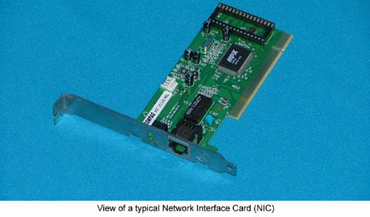
Short for Network Interface Card, a NIC is also commonly referred to as a network adapter and is an expansion card that enables a computer to connect to a network such as a home network and/or the Internet using a Ethernet cable with a RJ-45 connector.
Installation Process in Windows
- First step is to read the user's guide and familiarize yourself with the new card.
- Power down PC and remove the AC power cord.
- Open the computer case.
- Find an available Peripheral Component Interconnect (PCI) slot on the motherboard and remove slot insert if one exists.
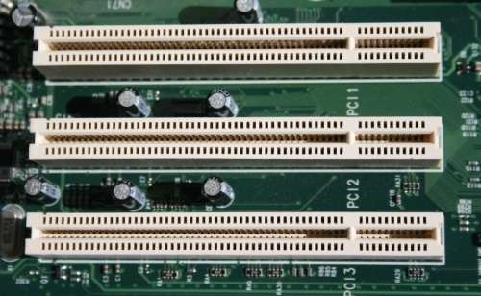
- Carefully remove the network card from its static-proof plastic envelope, and slide it into the slot.
- Seat the card in the slot firmly with gentle pressure along the length of the card, especially right about the slot itself.
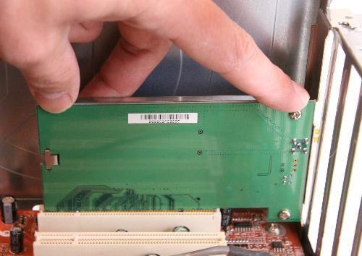
- Snugly, screw the card to the computer frame, but do not over tighten.
- Close the computer case.
- Plug your computer in and power it up.
- Click Start, then click Control Panel.
- In Category View (vs. Classic View) click Performance and Maintenance.
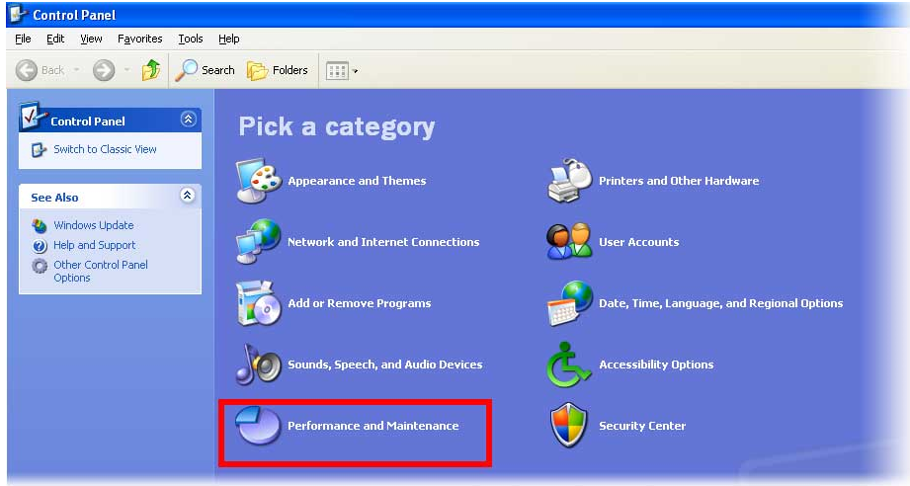
- Click "System" icon at bottom of window.
- Click the Hardware tab.
- Click the Device Manager button.
- Double-click Network Adapters.
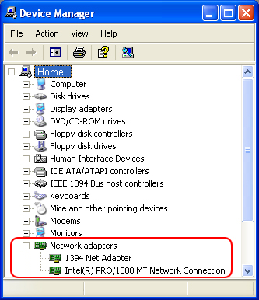
- Beneath it should appear the name of your Ethernet card.
- Next, double click the name of your Ethernet adapter.
- If the text in the "Device Status" box says "This device is working properly.", then you successfully installed the card and are finished.
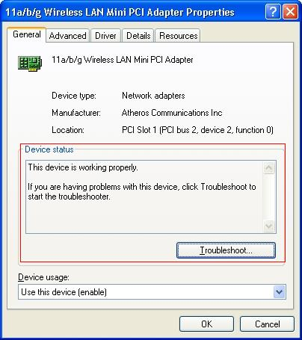
- If the text in the "Device status" box doesn't say "This device is working properly.", then write down on a piece of paper what it says and continue with next step.
Click the Troubleshoot. Button and follow instructions. Double check you followed the directions above. Install the most up to date device drivers.

